

**Placement Empowerment Program**

**Cloud Computing and DevOps Centre**

**Set Up a Virtual Machine in the Cloud** Create a free-tier Azure account. Launch a virtual machine and SSH into it.

Name: Aksha S Department: CSE

**Introduction**

Cloud computing enables businesses and developers to deploy and manage virtualized infrastructure efficiently. Microsoft Azure provides a scalable and cost-effective way to create Virtual Machines (VMs) for various workloads, from development to production environments.

This Proof of Concept (POC) demonstrates how to set up a Virtual Machine (VM) in Azure, configure it, and establish an SSH connection for remote access.

**Overview**

In this POC, we will:

1. Create an **Azure Free-Tier Account** (if not already done).
2. Launch a **Virtual Machine (VM)** using the Azure Portal.
3. Configure the VM with appropriate settings, such as OS, security rules, and SSH keys.
4. Establish an **SSH connection** to the VM from a local machine.

This process is essential for understanding cloud infrastructure management and virtualization in Azure.

**Objectives**

• Gain hands-on experience with **Azure Virtual Machines**.

• Learn how to configure **VM settings**, including authentication and networking.

• Understand how to **connect to a VM using SSH**.

• Explore the fundamental concepts of **cloud infrastructure** and **virtualization**.

• Ensure a secure and efficient cloud computing setup.

**Importance of Virtual Machines in Cloud Computing**

**✅ Scalability**

VMs allow businesses to scale applications quickly without investing in physical hardware.

**✅ Cost-Efficiency**

With pay-as-you-go pricing, organizations can optimize costs by provisioning only the necessary resources.

**✅ Flexibility & Accessibility**

Azure VMs support multiple OS options (Windows, Linux) and can be accessed from anywhere, enabling remote development and deployment.

**✅ Security & Reliability**

Azure provides built-in security features, automatic updates, and backup options, ensuring **high availability and disaster recovery**.

**✅ Testing & Development**

Developers can **test applications** in isolated environments without affecting production systems.

**Step-by-Step Overview**

**Create a Virtual Machine in Azure**

1. **Log in to** [**Azure Portal**](https://portal.azure.com/).
2. In the search bar, type **Virtual Machines** and select **Virtual Machines** from the results.
3. Click **+ Create → Azure Virtual Machine**.

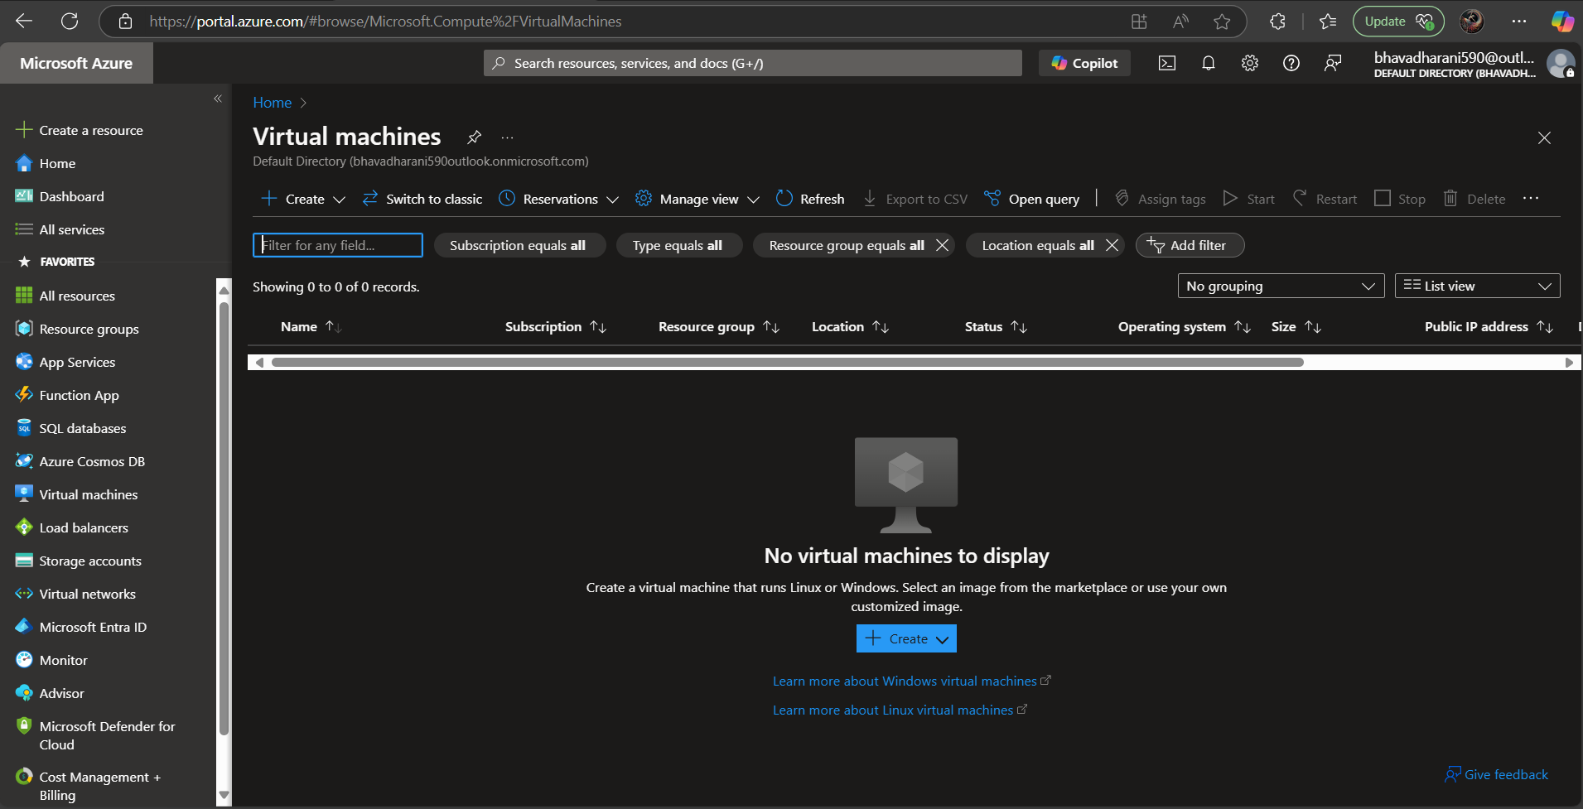

**Configure Basic Settings**

**Subscription**: Select the default free-tier subscription.  
 **Resource Group**: Click **Create new**, name it (e.g., MyResourceGroup).  
 **Virtual Machine Name**: Choose a name (e.g., MyAzureVM).  
 **Region**: Pick a nearby region (e.g., East US).  
 **Image**: Select **Ubuntu 22.04 LTS** (or Windows Server if preferred).

**Size**: Choose **Standard_B1s** (Free-tier eligible).

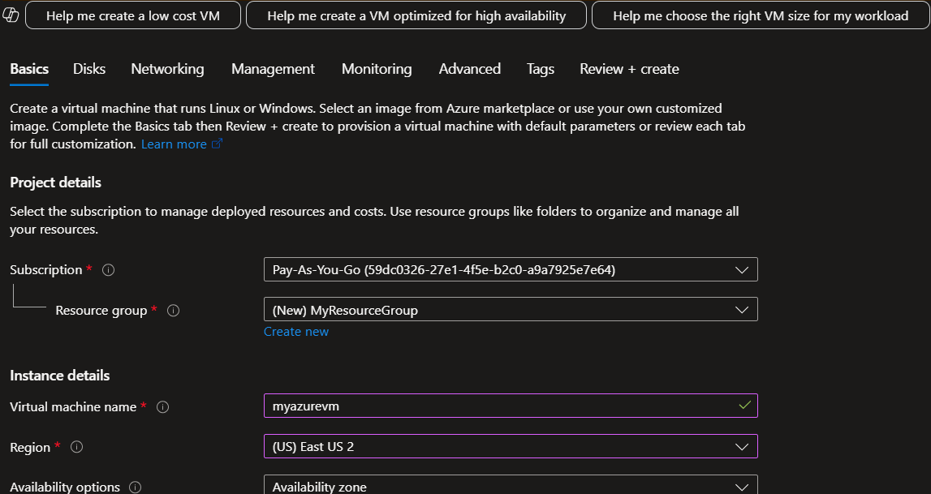

**Set Up Authentication (Login Credentials)**

**Authentication Type**: Select **SSH Public Key**.

**Username**: Choose a username (e.g., azureuser).🔹 **SSH Key**: Paste your public key (~/.ssh/id_rsa.pub).

* If you don’t have an SSH key, generate one:

ssh-keygen -t rsa -b 2048

* View your public key:

**cat ~/.ssh/id_rsa.pub**

* Copy and paste the key in Azure.

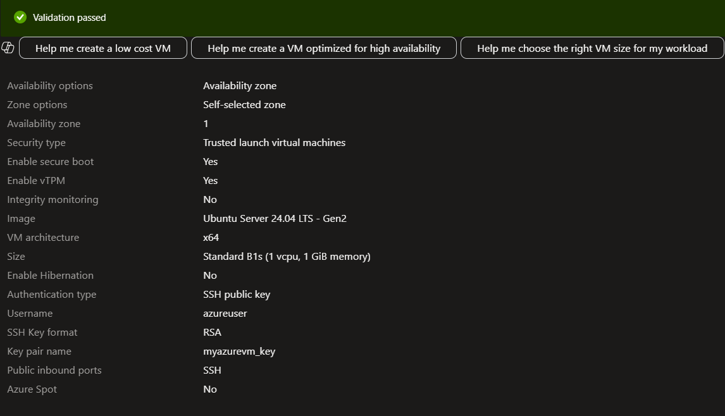

**Verify & Manage Your VM**

**✅ Update System Packages**

Run this inside the VM to update it:

**sudo apt update && sudo apt upgrade -y**

**✅ Install a Web Server (Optional)**

To test a web server, install **Nginx**:

sudo apt install nginx -y

Then, open a browser and visit:

http://<PUBLIC_IP>

You should see the default **"Welcome to Nginx"** page.

**✅ Stop, Start, or Delete the VM**

* **Stop the VM** (to avoid unnecessary usage):

az vm stop --resource-group MyResourceGroup --name MyAzureVM

* **Start the VM again**:

az vm start --resource-group MyResourceGroup --name MyAzureVM

* **Delete the VM (if no longer needed)**:

az vm delete --resource-group MyResourceGroup --name MyAzureVM --yes